Spring Newsletter 2025


BLOOD PRESSURE

A blood pressure test checks if your blood pressure is healthy, or if it's high or low. Blood pressure is the term used to describe the strength with which your blood pushes on the sides of your arteries as it's pumped around your body.

Low blood pressure (hypotension) is not usually a problem, although it can cause dizziness and fainting in some people.

High blood pressure (hypertension) can increase your risk of developing serious problems, such as heart attacks and strokes, if it's not treated. Raised blood pressure does not always present with symptoms until a problem occurs so getting it checked early can prevent developing a serious problem.

You should have a blood pressure test if you're worried about your blood pressure at any time.

If you have been diagnosed with high or low blood pressure, or you have a high risk of developing either, you may need more frequent checks of your blood pressure.

You can get your blood pressure tested at a number of places, including:
- most pharmacies
- your local GP surgery
- some workplaces

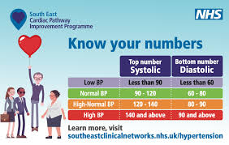

SASP Somerset Activity & Sports Partnership
Health & Wellbeing Coaching

Somerset Activity and Sports Partnership are dedicated to increasing the health and happiness of the residents in somerset. Here at Cannington Health Centre, we offer appointments with a health and well-being coach to support you with your physical and mental health.
Health and wellbeing coaches effectively support people to manage their own commitment and motivation in order to make positive change to their lifestyles. Health and wellbeing coaches can help those with long term conditions such as diabetes, cardiovascular, respiratory, stress and low mood, they can also help implement effective intervention to help support people with weight, diet and increasing activity.
Health and wellbeing coaches help individuals to create and reach their personalised goals and help change behaviours and unhealthy lifestyles.
To make an appointment with our Health Coach, SJ, please contact reception.

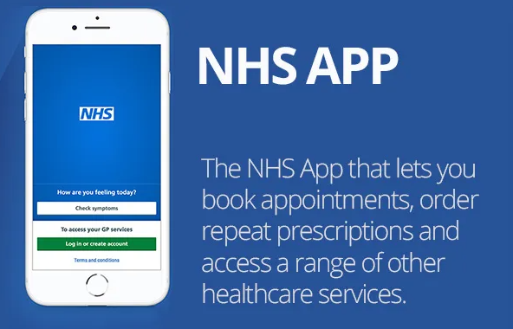
Online access to your GP record
The NHS app allows you to order your repeat prescriptions, view your GP record securely, view your booked appointments and so much more at just a touch of a button. if you want access to do all of this you can sign up through the NHS app or sign up through us here at Cannington Health Centre.

HAYFEVER

As the hay fever season begins, people who suffer from the allergy are being encouraged to visit their pharmacist, rather than their GP for help and advice.
You don’t need a prescription for hay fever medication, as the items can be easily purchased at your local pharmacy or local supermarket and are often much cheaper than the cost of an NHS prescription.
As well as over the counter medication, there are a number of ways that you can help protect yourself from symptoms of hay fever:

- Keep windows shut in the house and the car, especially when pollen counts are high.
- Avoid grassy areas, woodlands and avoid cutting the grass.
- Wear wrap-around sunglasses.
- After being outdoors, wash your hands, face, hair, rinse your eyes and change your clothes to avoid spreading pollen around your home.
- If possibly stay indoors when the pollen count is high.
- Smear a small amount of petroleum jelly, such as Vaseline inside your nose to help prevent pollen settling inside your nose.
- Don’t dry your washing outside to avoid pollen sticking to your clothes.
- You can also buy a pollen filter for the air vents in your car.

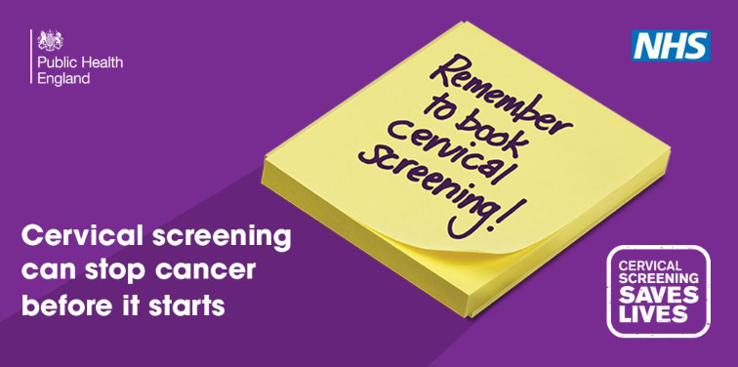
BOOK YOUR SMEAR NOW…

Cervical screening SAVES LIVES, preventing up to 7 in 10 incidences of cervical cancer. Despite this, almost 1 in 3 do not attend for their smear test when invited.
Women aged 25 to 49 are invited every 3 years
Women aged 50 – 64 are invited every 5 years
If you are invited for your smear, please do not delay in booking an appointment!!

MILITARY VETERANS

As a practice we are accredited as 'veteran friendly', otherwise known as 'armed forces friendly'.

78% of practices in Somerset are now 'Armed forces friendly' and we were amongst the first 9% to achieve this.

There are approximately 55,000 armed forces linked patients in the Somerset community. This includes veterans, active serving members of the armed forces, their families, and dependents of serving members.

If you are a military veteran, please contact us and let us know so we can ensure you get access to dedicated care and support. We are dedicated to improving our veteran’s health and quality of life and want to ensure you have the opportunity to benefit from the services we have on offer.

ORDERING & COLLECTING YOUR PRESCRIPTIONS

Did you know that you can order your repeat prescriptions online?
If you have an NHS account, you can order repeat prescriptions using the NHS website or the NHS App from a smartphone or tablet. This service will give you access to ordering repeat medication at your own convenience.

You may not be aware that your NHS account will track the status of your medication order and provide you progress updates. It is important to review the tracking, as requests can be rejected from within the parameters of the NHS account and not be delivered to the surgery’s system. Please keep a check on your medication order status as we do not wish for you to come to the surgery expecting your medication to be ready when the request has failed delivery, and a rejection message remains unactioned from within your account.

Many people prefer not to use the internet, in which case, please use the printed slip that comes with your medication to place your next order. Please allow 3 working days and only tick the items that you require.

Order Monday – Collect Thursday
Order Tuesday – Collect Friday
Order Wednesday – Collect Monday
Order Thursday – Collect Tuesday
Order Friday – Collect Wednesday

We would prefer you to use the above methods to order your prescription, but if you do need to order over the phone, please use the dedicated phone line which is open 9.30am – 11:00am and 15:00pm-16:00pm Monday to Friday. The telephone number is 01278 655464.

We are now using a text reminder service to tell you when your prescription is ready to collect (assuming we have the correct mobile number for you on record), if you have not received a message within 3 days of your request, please contact us to check the status of your prescription before coming to collect. Please also be aware that if you are out of signal when the message is sent you may not receive a message as it does not resend.

Prescriptions can be collected anytime from 8am - 6pm Monday to Friday.

Please be kind to our staff they are to help. Our staff try their best to work quickly and efficiently to help you, so please treat them with kindness and respect they deserve.

Please be kind to staff

KEEP YOUR RECORDS UP TO DATE

Please help us to keep your contact details up to date. If you change name, address, or telephone number, please let our receptionists know by calling in or by writing to us. Please note, if you move outside the practice area you will need to find a GP surgery in your new area.



You can now register to receive information by text message on your phone regarding appointments and health care. If you wish to register for the text messaging service, please let us know so your records can be updated to reflect this.

CHILDHOOD IMMUNISATIONS

The vaccinations that children receive in their early years are vital in helping them to build protection against infections such as meningitis, diphtheria, polio, measles and mumps.

Recently there has been an increase in measles cases around England, so stay protected and ensure your children are vaccinated.

If you have received a notification to book an
appointment, or if you are unsure whether your child has received all their due immunisations, please contact the reception team and we will do all that we can to help you. Alternatively, if you have any questions or concerns regarding vaccines, please book in for a telephone call to discuss this with a nurse or GP.

We hold a children’s vaccination clinic on the 1st Thursday of every month.

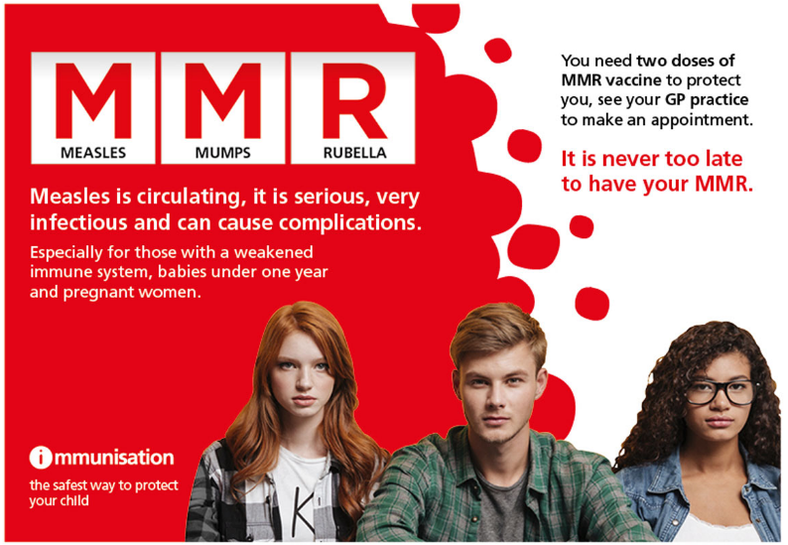

GPs are unable to advise or treat ANY dental issues.
Somerset residents who are not registered with a dental practice should call NHS 111 if they need urgent treatment or advice. Following an initial call with a call handler, you will be put through to a dental nurse who will advise on next steps. This could range from general self-care advice to an urgent appointment being booked within 48 hours.
You should call NHS 111 if you are suffering with severe dental pain that cannot be controlled with over-the-counter medication or if you have a dental or soft tissue infection.

GPs are not insured or trained to give dental advice.
DENTAL ISSUES

Victoria Park Health and Wellbeing Hub
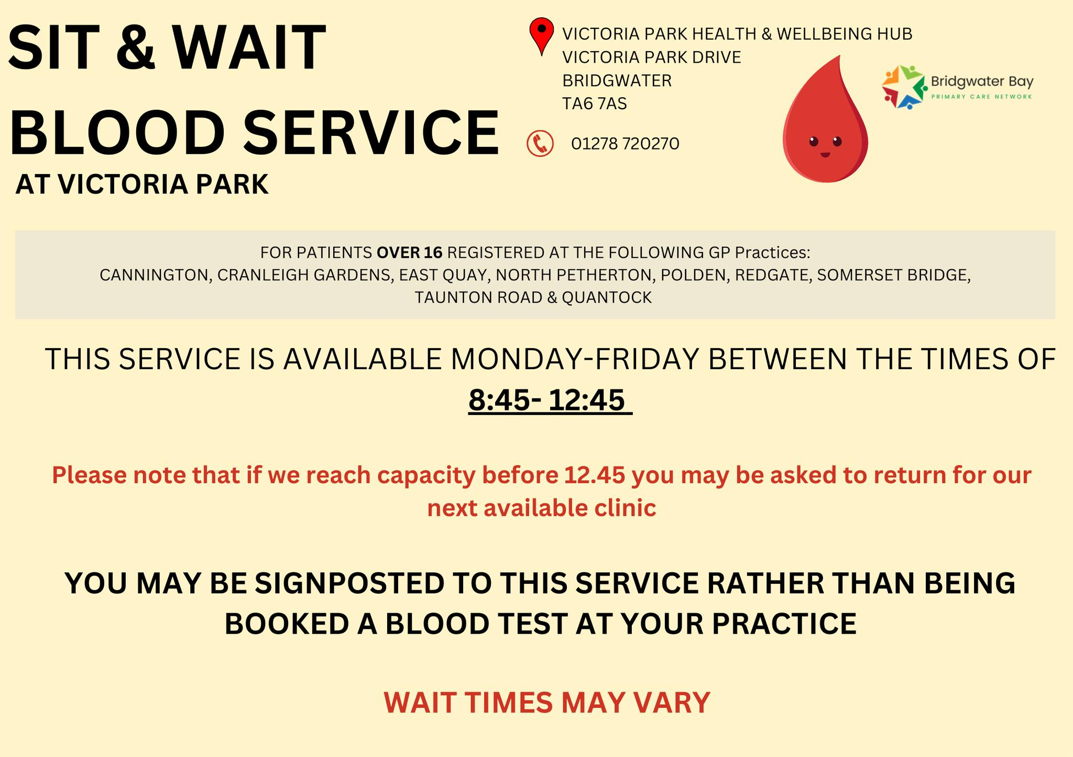

We want to say a massive thank you to everyone who has donated to our Bra Bank scheme, so far, we have donated 32 large boxes of bras to charity since we started the scheme at the end of June 2023.

These donations raise vital funds for research into secondary spread breast cancer. Together we can help raise funds for lifesaving research.

If you would like to donate, please find the collection box in the waiting room of Cannington Health Centre. Your support is very much appreciated.
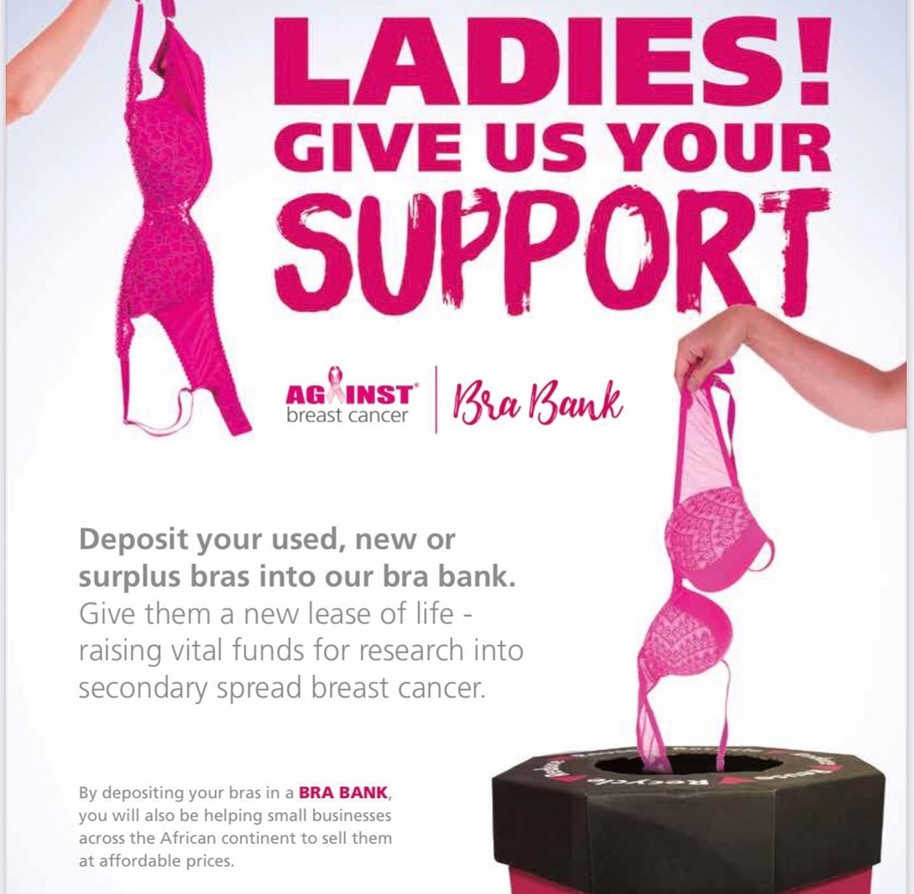
Bra Bank


